Session 4

Object Basics

Object is a superclass of all other classes.

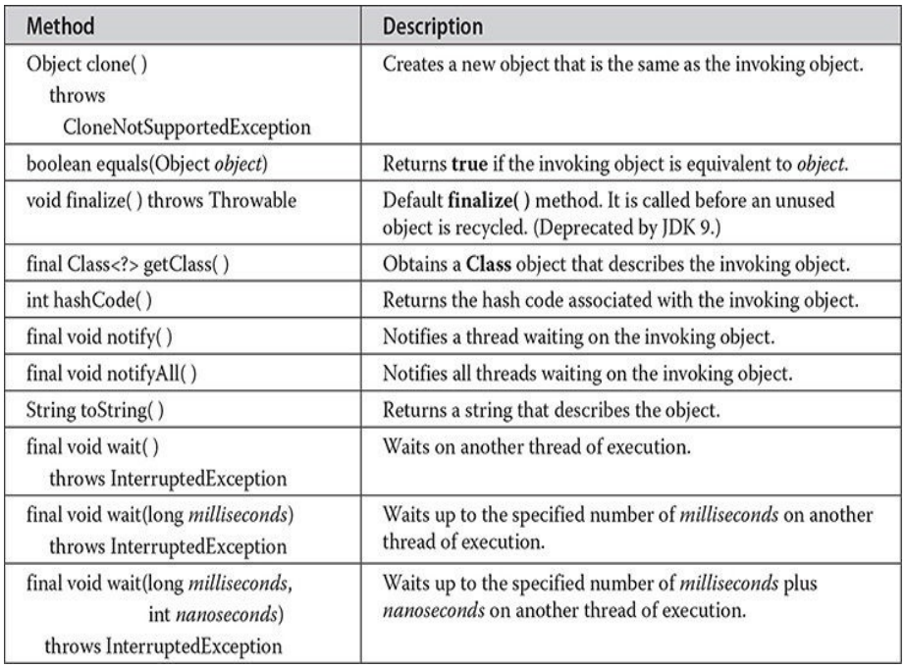

Object Life Cycle

We should know how objects are born, live their life, and then die at the end. There are following steps comes in the life cycle of object in java. They are as follows:

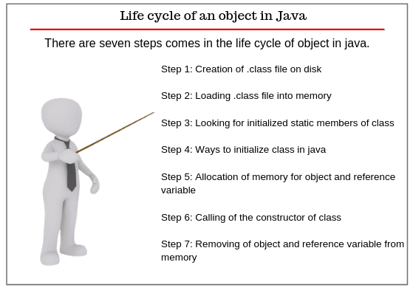

Step 1: Creation of .class file on disk

As you know that Java programs run on the Java virtual machine (JVM). When we compile the Java class, it is transformed into byte code which is platform and machine-independent. The compiled classes are stored as a .class file on a disk.

Step 2: Loading .class file into memory

After that, the Java runtime finds out that class on the disk that is in the form of a .class file. Java classloader loads that class into memory and then Java runtime reads it into the memory.

Step 3: Looking for initialized static members of class

Now Java looks for all initialized static members of the class such as static method, static field, and static block. You always remember that all the static members of the class do not belong to any particular instance of the class. It belongs to the class itself and is shared by all the objects created from the class.

Step 4: Ways to initialize class in java

A class can be initialized in two ways in Java. First, when you access a static field or static method of the class. For example, when you run the main method in a class, the class is initialized because the main method is static and the second way is when object or instance of the class is created using the new keyword, the class is initialized.

Step 5: Allocation of memory for object and reference variable

In stage 5, Java allocates the memory on the heap for the object and memory on the stack for object reference variable.

Step 6: Calling of the constructor of class

After allocating the memory, JVM calls the constructor of the class which is like a method but it is called only once when the object is created. Thus, the object lives its life and providing access to its fields and methods whatever we want and need to access them.

Step 7: Removing of object and reference variable from memory

When the accessing of field and methods are completed, the object and its reference are removed from the memory by the JVM. At this time the object has died.

You don’t have to destroy objects yourself. Actually, when the object is no longer in use, Java runtime calls the garbage collector to destroy all the objects. Thus, objects are created, used, and destroy.

Cleanup unused objects

Some object-oriented languages require that you keep track of all the objects you create, and that you explicitly destroy them when they are no longer needed. Managing memory explicitly is tedious and error-prone. The Java platform allows you to create as many objects as you want (limited, of course, by what your system can handle), and you don't have to worry about destroying them. The Java runtime environment deletes objects when it determines that they are no longer being used. This process is called garbage collection.

An object is eligible for garbage collection when there are no more references to that object. References that are held in a variable are usually dropped when the variable goes out of scope. Or, you can explicitly drop an object reference by setting the variable to the special value null. Remember that a program can have multiple references to the same object; all references to an object must be dropped before the object is eligible for garbage collection.

The Garbage Collector

The Java runtime environment has a garbage collector that periodically frees the memory used by objects that are no longer referenced. The garbage collector does its job automatically, although in some situations, you may want to explicitly request garbage collection by invoking the gc method in the System class. For example, you might want to do this after a section of code that creates a large amount of garbage, or before a section of code that needs a lot of memory. In most situations, however, it is enough to simply let the runtime enviroment run the garbage collector on its own, when it determines that the time is right.

Finalization

Before an object gets garbage-collected, the garbage collector gives the object an opportunity to clean up after itself through a call to the object's finalize method. This process is known as finalization.

Most programmers don't have to worry about implementing the finalize method. In rare cases, however, a programmer might have to implement a finalize method to release resources, such as native peers, that aren't under the control of the garbage collector.

The finalize method is a member of the Object class, which is the top of the Java platform's class hierarchy. It is the superclass of all classes. A class can override the finalize method to perform any finalization necessary for objects of that type. If you override finalize, your implementation of the method should call super.finalize as the last thing that it does. Overriding and Hiding Methods (in the Learning the Java Language trail) talks more about how to override methods.

Equals & Hash Code methods

Java.lang.object has two very important methods defined: public boolean equals(Object obj) and public int hashCode().

equals() method

In java equals() method is used to compare equality of two Objects. The equality can be compared in two ways:

Shallow comparison: The default implementation of equals method is defined in Java.lang.Object class which simply checks if two Object references (say x and y) refer to the same Object. i.e. It checks if x == y. Since Object class has no data members that define its state, it is also known as shallow comparison.

Deep Comparison: Suppose a class provides its own implementation of equals() method in order to compare the Objects of that class w.r.t state of the Objects. That means data members (i.e. fields) of Objects are to be compared with one another. Such Comparison based on data members is known as deep comparison.

Some principles of equals() method of Object class :

Reflexive: For any object x, x.equals(x) should return true.

Symmetric: For any two object x and y, x.equals(y) should return true if and only if y.equals(x) returns true.

Transitive: For multiple objects x, y, and z, if x.equals(y) returns true and y.equals(z) returns true, then x.equals(z) should return true.

Consistent: Multiple invocations of x.equals(y) should return same result, unless any of the object properties is modified that is being used in the equals() method implementation.

Object class equals() method implementation returns true only when both the references are pointing to same object.

equals() example

class Main {
public static void main(String[] args) {

// create an object using Object class
Object obj1 = new Object();

// assign obj1 to obj2
Object obj2 = obj1;

// check if obj1 and obj2 are equal
System.out.println(obj1.equals(obj2));

}
}

// Output: true

Importance of equals() and hashCode() method

Java hashCode() and equals() method are used in Hash table based implementations in java for storing and retrieving data.

The implementation of equals() and hashCode() should follow these rules.

If o1.equals(o2), then o1.hashCode() == o2.hashCode() should always be true.

If o1.hashCode() == o2.hashCode is true, it doesn’t mean that o1.equals(o2) will be true.

When to override equals() and hashCode() methods?

When we override equals() method, it’s almost necessary to override the hashCode() method too so that their contract is not violated by our implementation.

Note that your program will not throw any exceptions if the equals() and hashCode() contract is violated, if you are not planning to use the class as Hash table key, then it will not create any problem.

If you are planning to use a class as Hash table key, then it’s must to override both equals() and hashCode() methods.

HashCode() example:

class Main {
public static void main(String[] args) {

// hashCode() with Object
Object obj1 = new Object();

// assign obj1 to obj2
Object obj2 = obj1;

// check if two objects are equal
System.out.println(obj1.equals(obj2)); // true

// get hashcode of obj1 and obj2
System.out.println(obj1.hashCode()); // 1785210046
System.out.println(obj2.hashCode()); // 1785210046

}
}

In the above example, we can see that two objects obj1 and obj2 are generating the same hash code value.

It is because two objects are equal. And, according to official Java documentation, two equal objects should always return the same hash code value.

Clone

The clone( ) method generates a duplicate copy of the object on which it is called. Only classes that implement the Cloneable interface can be cloned.

The Cloneable interface defines no members. It is used to indicate that a class allows an exact copy of an object (that is, a clone) to be made. If you try to call clone( ) on a class that does not implement Cloneable, a CloneNotSupportedException is thrown. When a clone is made, the constructor for the object being cloned is not called. As implemented by Object, a clone is simply an exact copy of the original.

Cloning is a potentially dangerous action, because it can cause unintended side effects. For example, if the object being cloned contains a reference variable called obRef, then when the clone is made, obRef in the clone will refer to the same object as does obRef in the original. If the clone makes a change to the contents of the object referred to by obRef, then it will be changed for the original object, too. Here is another example: If an object opens an I/O stream and is then cloned, two objects will be capable of operating on the same stream. Further, if one of these objects closes the stream, the other object might still attempt to write to it, causing an error. In some cases, you will need to override the clone( ) method defined by Object to handle these types of problems.

Because cloning can cause problems, clone( ) is declared as protected inside Object. This means that it must either be called from within a method defined by the class that implements Cloneable, or it must be explicitly overridden by that class so that it is public.

Example

class Main implements Cloneable {

// declare variables
String name;
int version;
public static void main(String[] args) {

// create an object of Main class
Main obj1 = new Main();

// initialize name and version using obj1
obj1.name = "Java";
obj1.version = 14;

// print variable
System.out.println(obj1.name); // Java
System.out.println(obj1.version); // 14

try {

// create clone of obj1
Main obj2 = (Main)obj1.clone();

// print the variables using obj2
System.out.println(obj2.name); // Java
System.out.println(obj2.version); // 14
}
catch (Exception e) {
System.out.println(e);
}

}
}

In the above example, we have created a class named Main. The class includes two fields name and version. Here, we have initialize the class fields using the object obj1 of the class.
Notice the line,

Main obj2 = (Main)obj1.clone();

Here, we have used the clone() method to create copy of obj1. The value returned by clone() is assigned to the object obj2. Since the return value of clone() is Object type, we have used (Main) to convert it into Main type.

Now the fields name and version can be accessed using the object obj2. However if we change the value of the fields using obj2, the value associated with obj1 won't be changed.

Characters and Strings

In Java, the data type used to store characters is char. A key point to understand is that Java uses Unicode to represent characters. Unicode defines a fully international character set that can represent all of the characters found in all human languages. It is a unification of dozens of character sets, such as Latin, Greek, Arabic, Cyrillic, Hebrew, Katakana, Hangul, and many more. At the time of Java’s creation, Unicode required 16 bits. Thus, in Java char is a 16-bit type. The range of a char is 0 to 65,536. There are no negative chars.

A String is defined as a sequence or an array of characters. We have already covered the basics of String in our article Java Data types. We know that String in Java is not a primitive data type; instead, it is an object of class String.

Java Strings are one of the most common and widely used classes in Java programming. The String is an array of characters, and since arrays are immutable in nature, a String is an immutable object, which means they are constant, and we cannot change them after creating the objects.

Strings are a group of characters. In Java, you can work with the character data that is, a single character or a group of characters (Strings) in 4 different ways:

Character Class

It is a wrapper class whose objects hold single character data.

String Class

It is a class whose instances or objects can hold the unchanging or constant string (immutable String).

StringBuffer Class

Its instances or objects can hold mutable strings that can be changed or modified.

StringBuilder Class

Java StringBuilder class is similar to the StringBuffer class which holds a sequence of mutable Strings but is more versatile than StringBuffer class because it provides more modification features.

Creating Strings in Java

There are 2 ways of creating a String object:

By using a string literal

It is the most common way to create a String. Java String literal can be created just by using double-quotes.

String line = “Welcome to TechVidvan Java Tutorial” ;

By using a “new” keyword

Java String can also be created by using a new keyword with the String constructor.

String line = new String(“Welcome to TechVidvan Java Tutorial”);

Creating StringBuffers

StringBuffer objects are always created with a new operator. There are three ways by which you can create StringBuffer Objects:

1. Creating an empty StringBuffer object
StringBuffer sBuffer = new StringBuffer() ;

2. Creating and initializing the StringBuffer object
StringBuffer sBuffer = new StringBuffer( “ Hello World ” ) ;

3. Creating a StringBuffer object with an initial capacity equal to n
int n= 15;
StringBuffer sBuffer = new StringBuffer( n ) ;

Here, n is equal to 15 which is the number of characters. The object sBuffer has the capacity to hold 15 number of characters.

Methods of Java String Class

The methods of String class are used to obtain information about objects and are known as accessor methods. The String class provides many accessor methods that are used to perform operations on strings.
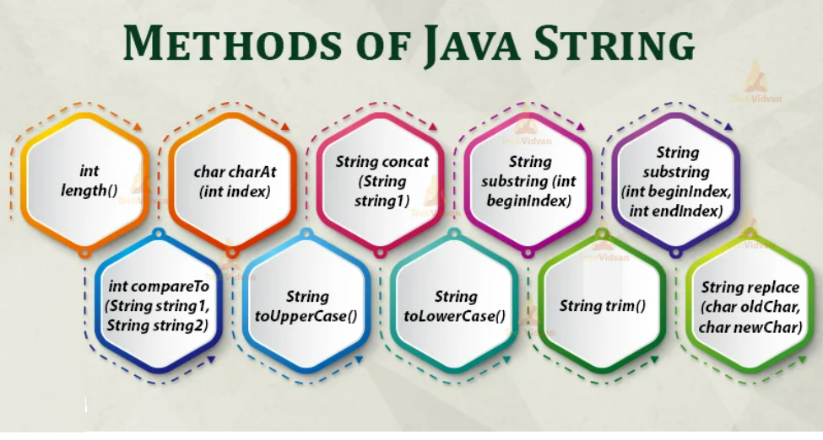
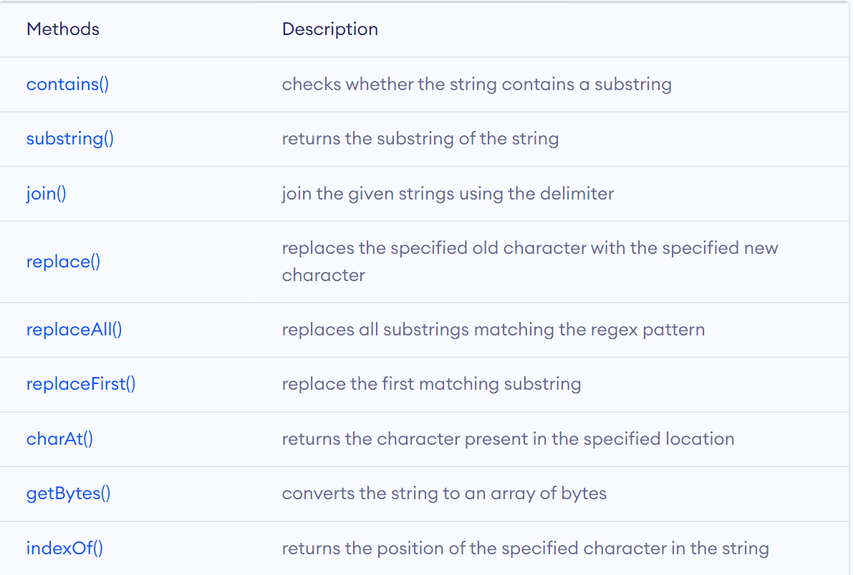
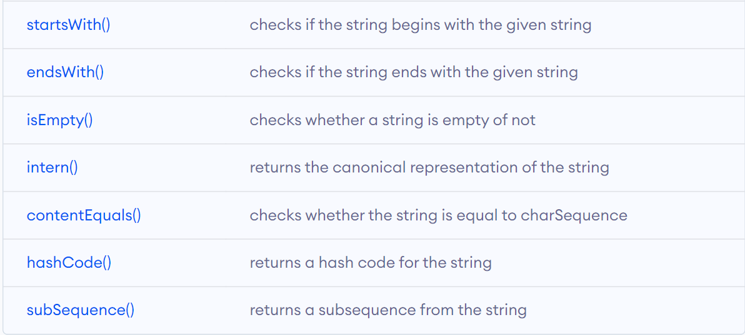
Wrapper class

As you know, Java uses primitive types (also called simple types), such as int or double, to hold the basic data types supported by the language. Primitive types, rather than objects, are used for these quantities for the sake of performance. Using objects for these values would add an unacceptable overhead to even the simplest of calculations. Thus, the primitive types are not part of the object hierarchy, and they do not inherit Object.

Despite the performance benefit offered by the primitive types, there are times when you will need an object representation. For example, you can’t pass a primitive type by reference to a method. Also, many of the standard data structures implemented by Java operate on objects, which means that you can’t use these data structures to store primitive types. To handle these (and other) situations, Java provides type wrappers, which are classes that encapsulate a primitive type within an object.

The type wrappers are Double, Float, Long, Integer, Short, Byte, Character, and Boolean. These classes offer a wide array of methods that allow you to fully integrate the primitive types into Java’s object hierarchy.

Byte, Short, Integer, and Long

The Byte, Short, Integer, and Long classes are wrappers for byte, short, int, and long integer types, respectively. Their constructors are shown here:

Byte(byte num)
Byte(String str) throws NumberFormatException

Short(short num)
Short(String str) throws NumberFormatException

Integer(int num)
Integer(String str) throws NumberFormatException

Long(long num)
Long(String str) throws NumberFormatException

As you can see, these objects can be constructed from numeric values or from strings that contain valid whole number values. Beginning with JDK 9, these constructors have been deprecated. The valueOf( ) method is the recommended alternative.

Converting Numbers to and from Strings

One of the most common programming chores is converting the string representation of a number into its internal, binary format. Fortunately, Java provides an easy way to accomplish this. The Byte, Short, Integer, and Long classes provide the parseByte( ), parseShort( ), parseInt( ), and parseLong( ) methods, respectively. These methods return the byte, short, int, or long equivalent of the numeric string with which they are called. (Similar methods also exist for the Float and Double classes.)

Exception Handling

An exception is an unexpected event that occurs during program execution. It affects the flow of the program instructions which can cause the program to terminate abnormally.

An exception can occur for many reasons. Some of them are:

Invalid user input
Device failure
Loss of network connection
Physical limitations (out of disk memory)
Code errors
Opening an unavailable file

Java Exception hierarchy

Here is a simplified diagram of the exception hierarchy in Java.

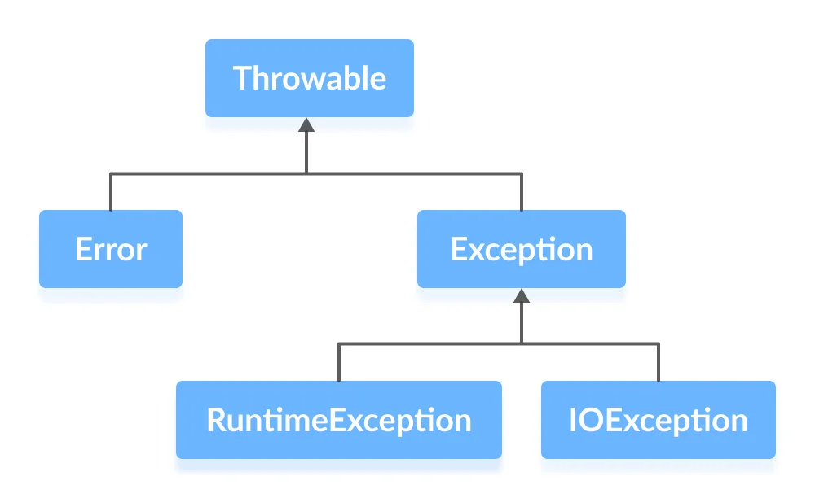

As you can see from the image above, the Throwable class is the root class in the hierarchy.

Note that the hierarchy splits into two branches: Error and Exception.

Errors

Errors represent irrecoverable conditions such as Java virtual machine (JVM) running out of memory, memory leaks, stack overflow errors, library incompatibility, infinite recursion, etc.

Errors are usually beyond the control of the programmer and we should not try to handle errors.

Exceptions

Exceptions can be caught and handled by the program.

When an exception occurs within a method, it creates an object. This object is called the exception object.

It contains information about the exception such as the name and description of the exception and state of the program when the exception occurred.

1. RuntimeException

A runtime exception happens due to a programming error. They are also known as unchecked exceptions.

These exceptions are not checked at compile-time but run-time. Some of the common runtime exceptions are:

Improper use of an API - IllegalArgumentException
Null pointer access (missing the initialization of a variable) - NullPointerException
Out-of-bounds array access - ArrayIndexOutOfBoundsException
Dividing a number by 0 - ArithmeticException
You can think about it in this way. “If it is a runtime exception, it is your fault”.

The NullPointerException would not have occurred if you had checked whether the variable was initialized or not before using it.

An ArrayIndexOutOfBoundsException would not have occurred if you tested the array index against the array bounds.

2. IOException

An IOException is also known as a checked exception. They are checked by the compiler at the compile-time and the programmer is prompted to handle these exceptions.

Some of the examples of checked exceptions are:

Trying to open a file that doesn’t exist results in FileNotFoundException
Trying to read past the end of a file

Java exception handling is managed via five keywords: try, catch, throw, throws, and finally. Program statements that you want to monitor for exceptions are contained within a try block. If an exception occurs within the try block, it is thrown. Your code can catch this exception (using catch) and handle it in some rational manner. System-generated exceptions are automatically thrown by the Java run-time system. To manually throw an exception, use the keyword throw. Any exception that is thrown out of a method must be specified as such by a throws clause. Any code that absolutely must be executed after a try block completes is put in a finally block.

User-defined Exception

Java provides us the facility to create our own exceptions which are basically derived classes of Exception. Creating our own Exception is known as a custom exception or user-defined exception. Basically, Java custom exceptions are used to customize the exception according to user needs. In simple words, we can say that a User-Defined Exception or custom exception is creating your own exception class and throwing that exception using the ‘throw’ keyword.

Why to use custom exceptions?

Business logic exceptions: These are the exceptions related to business logic and workflow. It is useful for the application users or the developers to understand the exact problem.

Example:

class MyException extends Exception {
public MyException(String s)
{
// Call constructor of parent Exception
super(s);
}
}

